Call for Erasmus+ Staff Mobility for Teaching

Key Action 1 of the Erasmus+ Program provides funds for short term teaching visits of faculty members to partner institutions. This program is called the Teaching Staff Mobility (TSM), and at Abdullah Gül University program coordinated by the Erasmus Office.

Funding

The faculty members participating in the program may receive funding, including contributions for travel costs and subsistence during the period abroad. The subsistence grant is a contribution towards all other costs for the individual including travel within the city, accommodation, meals and snacks.

Funding for travel expenses: For each participant, the distance for travel is calculated by below ‘Distance Calculator’ provided by European Commission:
http://ec.europa.eu/programmes/erasmus-plus/tools/distance_en.htm

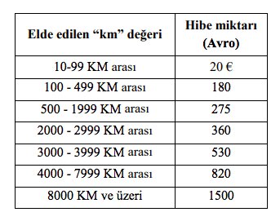
Funding per day: The amount of support provided per day per country is determined by the National Agency (www.ua.gov.tr).

EU Grant support for the Mobility of staff
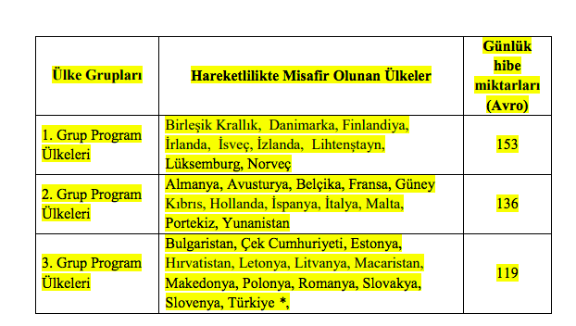
Table 1: Daily Amounts for Erasmus+ Teaching/ Traing Staff Mobility
Duration of mobility

The eligibility period of the Erasmus+ Mobility for Teaching should be between the 01/06/2019 – 31/05/2021.

Please note that all mobility activities must end before May 20, 2021.

The minimum duration for Erasmus+ Mobility for teaching is 2 days and the maximum duration is 2 months.

To increase the number of participants, Abdullah Gül University funds;

- Mobilities for at most five days two of which may be used for travel. Depending on the available funds extra days may also be reimbursed

In all cases, a teaching activity has to comprise a minimum of 8 hours teaching per week and you must be a full time faculty member to apply. If your teaching period is more than 3 days, your teaching activity has to comprise minimum 10 hours.

In order to be eligible for the subsistence grants, beneficiaries will need to make travel arrangements for their mobility period up to one day before and one day after the actual teaching mobility dates.

How to apply

To be able to participate in TSM, your Department/School/Faculty/Institute must have a valid agreement with the partner institution you intend to visit. If you wish to visit an institution that is not yet our partner, we urge you to contact your Department’s / School’s / Faculty’s / Institute’s Erasmus Coordinator to initiate the procedure for signing a new agreement. Please note that an institution must have an Erasmus Charter to be able to take part in this mobility. The list of all institutions with Erasmus Charters is provided at: https://eacea.ec.europa.eu/erasmus-plus/actions/erasmus-charter_en

Faculty members should contact the corresponding department of the partner institution, communicate and arrange his/her own Erasmus exchange visit. The host institution may assist you in finding on or off- campus housing and send you an invitation letter for the visa, if needed.

All faculty members who wish to take part in TSM should send, via e-mail, application form, Teaching Staff Mobility Form, invitation letter, work plans, the names of the partner institution and the academic unit they wish to visit, and the expected dates of their mobility, to erasmus@agu.edu.tr no later than October 23, 2019, 17:00.

Selection Criteria

Official letters of invitation from the partner universities and approved work plans should be submitted to our Office before the date above.

- At least one year of work experience at AGU: + 5 points
- For each extra year of work experience at AGU: + 5 points
- Currently, Erasmus Department Coordinator/Assistant: +10 points
- Previous Erasmus Department Coordinator/Assistant: + 5 points
- First time Erasmus applicant: +30 points
- Academic personnel of Faculties/Schools with Ph.D. Titles: +30 points
- Support academic personnel of Faculties/Schools with M.Sc./M.A Titles: +20 points
- Support academic personnel of Faculties/Schools with B.Sc./B.A Titles: +10 points
- Language Level 1 : + 40 points for KPDS/YDS .GE. 90, TOEFL IBT .GE. 108
Language Level 2 : + 30 points for KPDS/YDS .GE. 80, TOEFL IBT .GE. 96
Language Level 3 : + 20 points for KPDS/YDS .GE. 70, TOEFL IBT .GE. 84
Language Level 4 : + 10 points for KPDS/YDS .GE. 60, TOEFL IBT .GE. 72
Here .GE. stands for “Greater than or Equal to”. One can get a Language Point from only one of the Language Levels.
- For presentation proposals that introduces the research activities, their budgets and the project based RA scholarships at AGU: +10 points
- For presentation proposals that promotes the joint research collaborations between the two institutions: +10 points
- For presentation proposals that promotes graduate studies at AGU for candidate grad students: +10 points
- For presentation proposals that promotes academic exchange activities between the two institutions: +10 points
- For presentation proposals that promotes undergrad and grad student exchange activities between the two institutions: +10 points

P.S: All applicants will present their mobility details in the committee meeting. (5 minutes)

Any faculty member wishing to do so may take part in TSM without requesting financial support.

Applicants, who will not be awarded a grant on the basis of lack of funding, will remain on a reserve list and will be awarded grants if funds become available in due course.

Please visit www.erasmus.agu.edu.tr for information regarding partners, Erasmus + coordinators, sample of documents and other related issues.

If you need any further information please do not hesitate to contact us via e-mail erasmus@agu.edu.tr.

